Business Case Study for GlobalCare Medical Solutions (GCMS)
1. Script Output
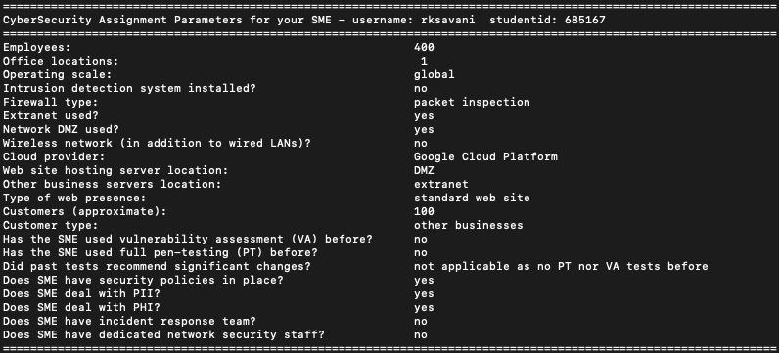
2. Overview of the Business
GlobalCare Medical Solutions (GCMS) is a healthcare-focused SME that provides medical data processing, telehealth integrations, and logistics support to hospitals, clinics, and research centers worldwide. Founded five years ago, GCMS operates primarily from a single office in Melbourne, Australia, yet maintains a global client base. The company currently employs around 400 staff, including medical data analysts, software developers, administrative personnel, and an executive leadership team.
GCMS manages sensitive data such as Personally Identifiable Information (PII) and Protected Health Information (PHI) on behalf of its clients, who rely on the company for both secure storage and efficient data handling. Although GCMS has security policies in place covering areas like password complexity and user access levels, these have not been comprehensively audited. To date, the organization has not undergone a formal vulnerability assessment or penetration test, leaving its overall security posture largely unverified.

3. Organizational Hierarchy & Roles
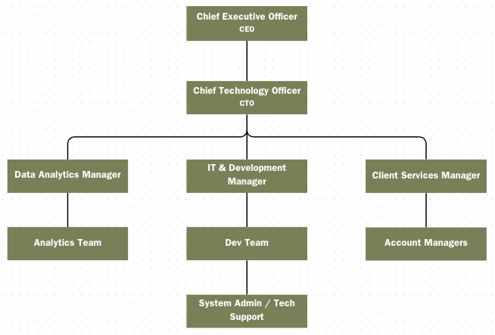
Key Roles:
- CEO: Oversees strategy, partnerships, and high-level decision-making.
- CTO: Manages overall IT operations, data security, and compliance oversight.
- IT & Development Team: Maintains servers, network components, and key applications.
- Data Analytics Team: Handles medical data integration, reporting, and service design.
- Client Services: Manages customer onboarding, day-to-day logistics, and support queries.

4. ICT Infrastructure
4.1 Physical Location & Network
GCMS operates a fully wired Ethernet network within its single office. A packet inspection firewall secures the organization’s perimeter, although there is no intrusion detection system (IDS). The absence of a wireless network simplifies some aspects of security but increases reliance on strict wired network segmentation.
4.2 DMZ & Extranet
A dedicated DMZ hosts the company’s public-facing website and a client portal for secure file exchanges. An extranet environment facilitates collaboration with external partners, offering a staging area for testing and development servers. This extranet is reachable from the internet for certain authorized partners, though no formal audits have been performed to ensure it is configured securely.
4.3 Cloud Infrastructure (Google Cloud Platform)
GCMS stores much of its internal data (patient records, analytics workloads, administrative tools) in Google Cloud Platform (GCP). Employees access GCP services via a secure VPN and basic multifactor authentication. While GCP offers robust native security features, GCMS has never commissioned a third-party review or vulnerability scan of its cloud configurations, creating potential gaps in visibility.
4.4 Endpoints & Desktop Applications
GCMS maintains approximately 380 Windows 10/11 desktops and around 20 Linux workstations. Users rely on Microsoft 365 (including Outlook for email and Teams for internal communication) for day-to-day tasks. Many teams also use specialized healthcare data-analysis applications. The endpoint protection strategy involves Windows Defender on Windows machines and ClamAV on Linux devices. However, there is no centralized endpoint management platform to ensure consistent patching or compliance.
4.5 Server Applications
- Mail Server: Microsoft Exchange, hosted on a VM in GCP, handles all inbound and outbound email.
- Backup Server: Nightly data backups run to a secure GCP storage bucket, but retention policies have not been formally reviewed.
- File Server: A dedicated virtual machine on the extranet provides secure document sharing with business partners.
- DNS: Internally managed through a BIND DNS server in the extranet environment; external DNS entries are managed by the domain registrar.
- ERP/Finance: GCMS uses a cloud-based ERP for billing and financial workflows, although exact auditing controls are unclear.
- HRMS: A lightweight HR management system is hosted internally to handle staff records and payroll processes.
5. Data Sensitivity & Regulatory Environment
GCMS handles PHI and PII for healthcare providers globally, making compliance with regulations such as HIPAA and the GDPR crucial. Although minimal references exist in GCMS’s written policies about these standards, the extent of alignment with international data protection laws is uncertain. Any misconfiguration or security oversight could expose both patient confidentiality and client trust to significant risk.

6. Current Gaps & Rationale for a Vulnerability Assessment
The main security gaps at GCMS include:
- No IDS or real-time monitoring, hindering timely threat detection.
- Unverified cloud configurations, particularly across GCP’s complex permission settings.
- Decentralized endpoint security with no unified patch management or update enforcement.
- Limited internal audits of firewall rules, DMZ, and extranet configurations.
Given the high stakes for health data and the global reach of its clientele, GCMS’s executive leadership recognizes the need to identify vulnerabilities before they can be exploited. A formal vulnerability assessment would provide actionable insights into technical and procedural weaknesses within the company’s infrastructure, helping reduce the risk of data breaches and non-compliance with healthcare data regulations.

7. Assumptions
- Budget Constraints: GCMS lacks the capacity to hire dedicated security personnel or purchase new security systems during the assessment period.
- Limited Disruption: Any security testing must avoid major interruptions to day-to-day healthcare data processing.
- Existing Policies: Although basic policies exist, they have not been validated by external auditors.

Generative AI Acknowledgment
I used ChatGPT to help with grammar and spelling of this Business Case Study. Prompts used included:
1. “Check grammar and spelling mistakes.”

